**Assessment – 1**

**Matam Preethi**

**Amrita Vishwa Vidyapeetham**

**CB.EN.U4CSE20438**

NVD - CVE API: The CVE API is used to easily retrieve information on a single CVE or a collection of CVE from the NVD. Pls refer to the below NVD CVE documentation to get more information.

Flowchart

**Used coding language-Python**

**Database-Sqlite3**

**Framework-Flask**

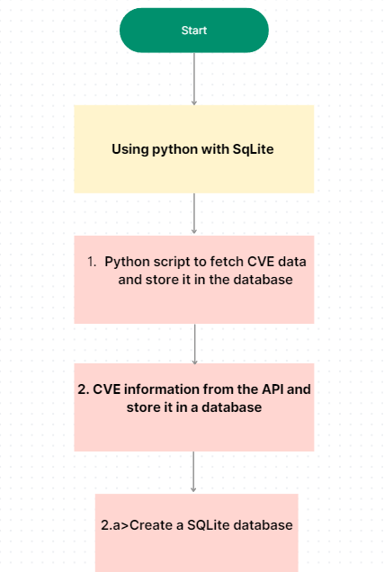

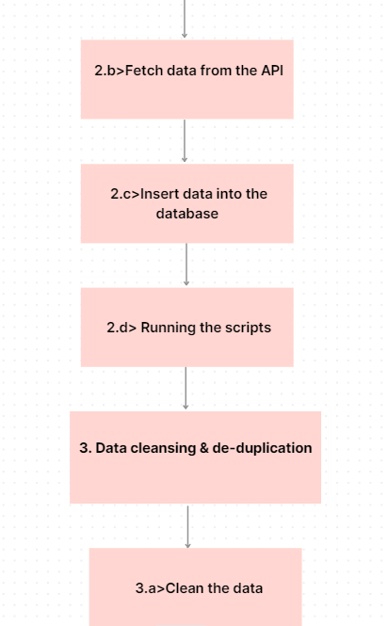

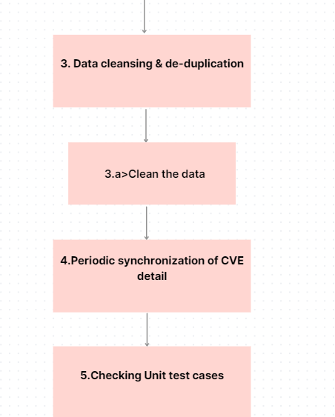

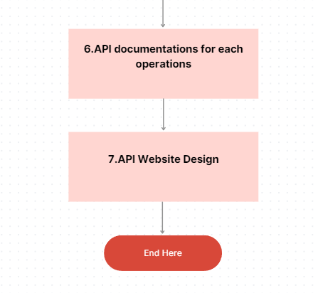

Steps to develop

Important installation

1.sqlite3

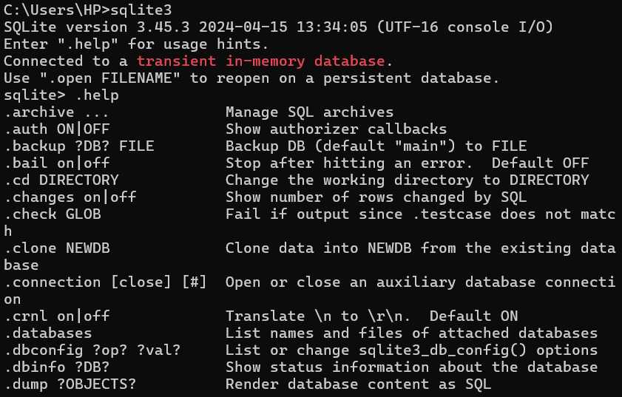

2. Installation of Requests library, which is used for making HTTP requests in Python.

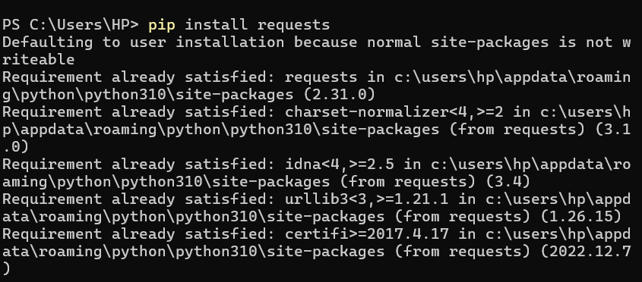

3.Flask

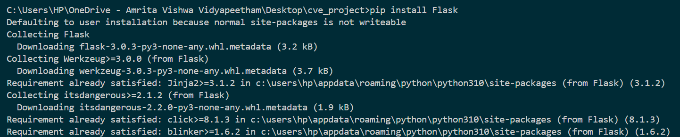

**Step 1 :- CVE Information and Database Storage (main.py):**

import time

import requests

import json

import sqlite3

**def** get_cves(start_index, results_per_page):

    url = f"https://services.nvd.nist.gov/rest/json/cves/2.0?startIndex={start_index}&resultsPerPage={results_per_page}"

    response = requests.get(url)

    if response.status_code == 200:

        return response.json()

    elif response.status_code == 403:  *# Handle rate limiting*

        print(f"Rate limit reached! Sleeping for 10 seconds...")

        time.sleep(10)  *# Adjust delay based on NVD API rate limits*

        return get_cves(start_index, results_per_page)  *# Retry after delay*

    else:

        raise Exception(f"Error retrieving CVEs: {response.status_code}")

**def** store_cves(cves):

    conn = sqlite3.connect("cve_data.db")

    cursor = conn.cursor()

*# Create table with appropriate data types (adjust as needed)*

    cursor.execute("""CREATE TABLE IF NOT EXISTS cves (

        cve_id **TEXT** **PRIMARY KEY**,

        published_date **TEXT**,

        lastModifiedDate **TEXT**,

        description **TEXT**,

        cvss_v2_score **REAL**,

        cvss_v3_score **REAL**

    )""")

    for cve in cves.get("results", []):

        data = (

            cve["cve_id"],

            cve["publishedDate"],

            cve["lastModifiedDate"],

            cve["description"]["description_data"][0]["value"],

            cve.get("impact", {}).get("baseMetricV2", {}).get(

                "cvssData", {}).get("baseScore"),

            cve.get("impact", {}).get("baseMetricV3", {}).get(

                "cvssData", {}).get("baseScore"),

        )

        cursor.execute(

            "INSERT OR IGNORE INTO cves VALUES (?, ?, ?, ?, ?, ?)", data)

    conn.commit()

    conn.close()

**def** main():

    start_index = 0

    results_per_page = 50  *# Adjust as needed*

    while True:

        cves = get_cves(start_index, results_per_page)

        if not cves.get("totalResults", 0):

            break

        store_cves(cves)

        start_index += results_per_page

if __name__ == "__main__":

    main()

**Step 2:-The CVE information from the API and store it in a database**

**Step:- 2.a> Create a SQLite database**

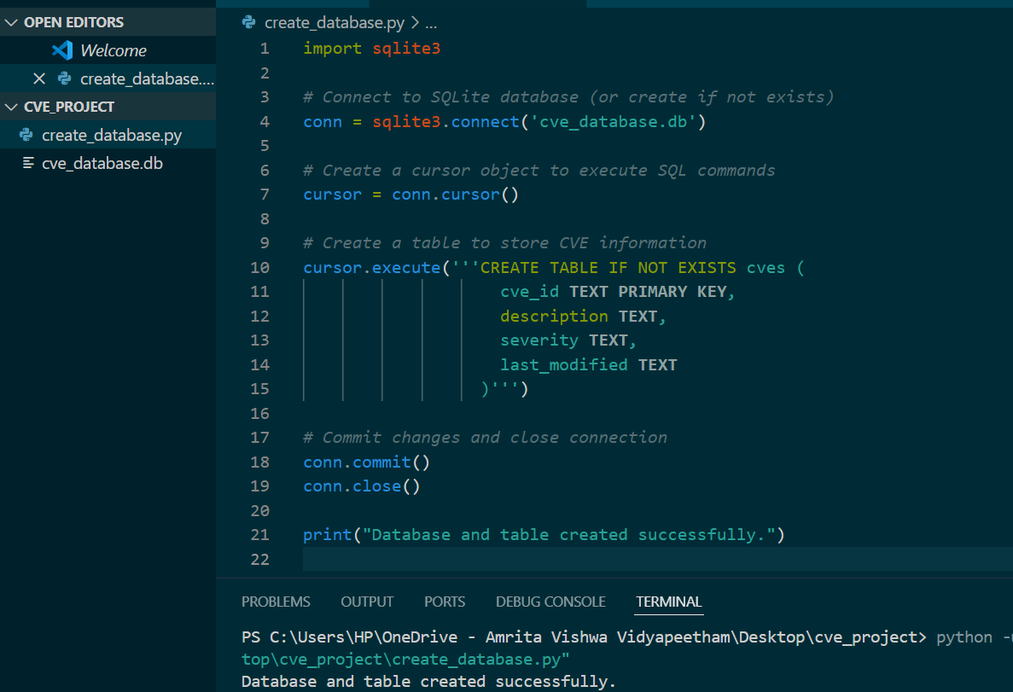

**Step-2.b>Fetch data from the API**

import requests

**def** fetch_cve_data(start_index, results_per_page):

    base_url = 'https://services.nvd.nist.gov/rest/json/cves/2.0'

    params = {

        'startIndex': start_index,

        'resultsPerPage': results_per_page

    }

    response = requests.get(base_url, params=params)

    data = response.json()

*# Check if 'result' key exists in the response*

    if 'result' in data:

        return data['result']['CVE_Items']

    else:

*# If 'result' key doesn't exist, return an empty list*

        return []

*# Example usage*

cve_data = fetch_cve_data(0, 10)

print(cve_data)

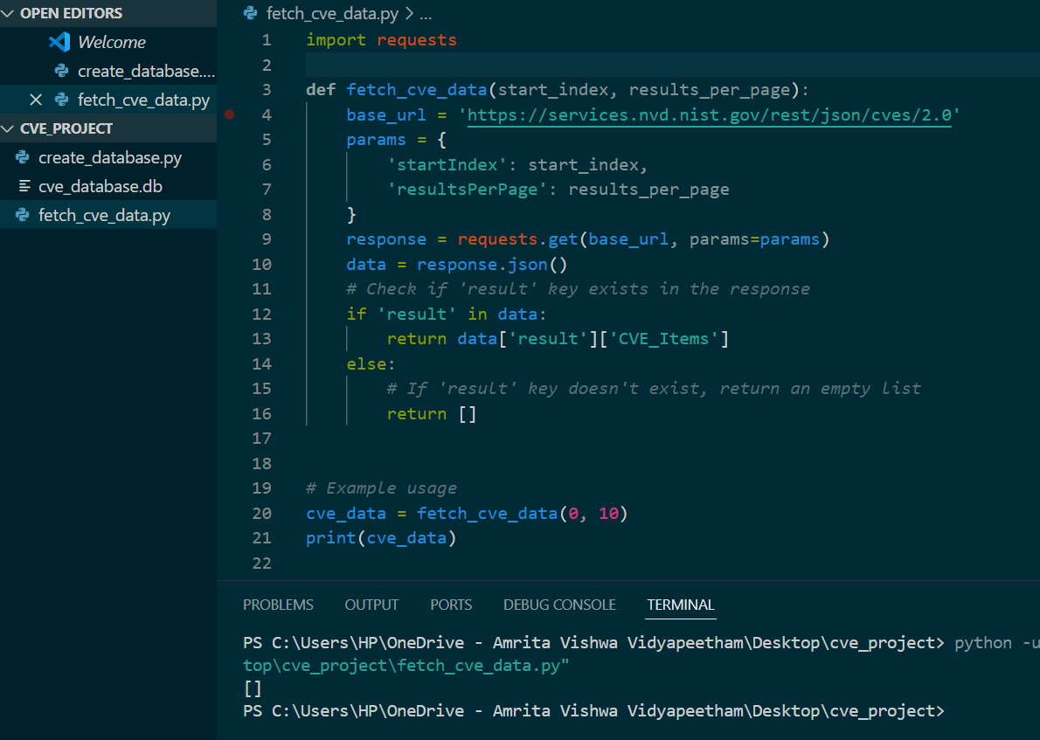

**Step-2.c> Insert data into the database**

import sqlite3

import requests

**def** fetch_cve_data(start_index, results_per_page):

    base_url = 'https://services.nvd.nist.gov/rest/json/cves/2.0'

    params = {

        'startIndex': start_index,

        'resultsPerPage': results_per_page

    }

    response = requests.get(base_url, params=params)

    data = response.json()

    return data['vulnerabilities']

**def** insert_cve_data_into_database(cve_data):

    conn = sqlite3.connect('cve_database.db')

    cursor = conn.cursor()

*# Create the table if it doesn't exist*

    cursor.execute('''CREATE TABLE IF NOT EXISTS cves

                     (cve_id **TEXT**, description **TEXT**, severity **TEXT**, last_modified **TEXT**)''')

    for cve_item in cve_data:

        cve_id = cve_item['cve']['id']

*# Extract description*

        if 'description' in cve_item['cve']:

            if 'descriptions' in cve_item['cve']['description']:

                description = cve_item['cve']['description']['descriptions'][0]['value']

            else:

                description = None

        else:

            description = None

*# Extract severity*

        if 'impact' in cve_item and 'baseMetricV3' in cve_item['impact']:

            severity = cve_item['impact']['baseMetricV3']['cvssV3']['baseSeverity']

        else:

            severity = None

*# Extract last modified date*

        if 'lastModifiedDateStr' in cve_item:

            last_modified = cve_item['lastModifiedDateStr']

        else:

            last_modified = None

        cursor.execute('''INSERT OR IGNORE INTO cves (cve_id, description, severity, last_modified)

                          VALUES (?, ?, ?, ?)''', (cve_id, description, severity, last_modified))

    conn.commit()

    conn.close()

*# Example usage*

cve_data = fetch_cve_data(0, 10)

insert_cve_data_into_database(cve_data)

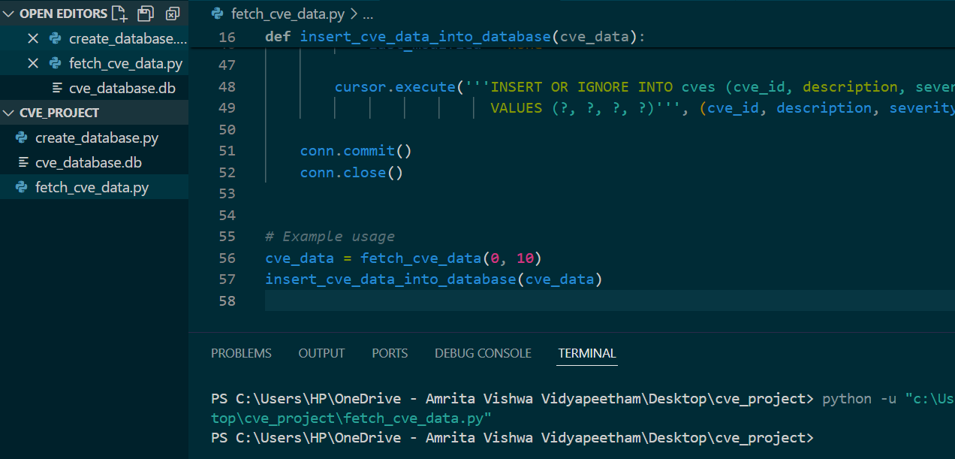

Step-2.d> **Running the scripts:**

**python create_database.py**

**python fetch_cve_data.py**

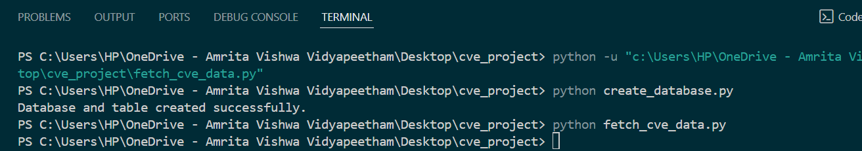

**Step 3: Data cleansing & de-duplication**

**Step 3.a>Clean the data: Perform data cleansing operations such as removing duplicates, handling missing values, etc.**

1. import sqlite3
2. conn = sqlite3.connect('cve_database.db')
3. cursor = conn.cursor()
4. *# Identify duplicates*
5. cursor.execute('''SELECT cve_id, COUNT(*)
6. FROM cves
7. GROUP BY cve_id
8. HAVING COUNT(*) > 1''')
9. duplicates = cursor.fetchall()
10. *# Remove duplicates*
11. for cve_id, count in duplicates:
12. cursor.execute('''DELETE FROM cves
13. WHERE rowid NOT IN (SELECT MIN(rowid)
14. FROM cves
15. WHERE cve_id = ?
16. GROUP BY cve_id)''', (cve_id,))
17. *# Identify missing values*
18. cursor.execute('''SELECT *
19. FROM cves
20. WHERE severity IS NULL OR description IS NULL OR last_modified IS NULL''')
21. missing_values = cursor.fetchall()
22. *# Handle missing values*
23. *# 1.Deleting rows with missing values*
24. for row in missing_values:
25. cve_id = row[0]
26. cursor.execute('''DELETE FROM cves WHERE cve_id = ?''', (cve_id,))
28. *# 2.Updating missing values*
29. for row in missing_values:
30. cve_id = row[0]
31. cursor.execute(
32. '''UPDATE cves SET severity = ? WHERE cve_id = ?''', ('Unknown', cve_id))
33. *# 3.Imputation:-Impute missing values with the mean, median, or mode of the respective column.*
34. for row in missing_values:
35. cve_id = row[0]
36. *# Replace missing severity with the mean severity*
37. cursor.execute(
38. '''UPDATE cves SET severity = (SELECT AVG(severity) FROM cves WHERE severity IS NOT NULL) WHERE cve_id = ?''', (cve_id,))

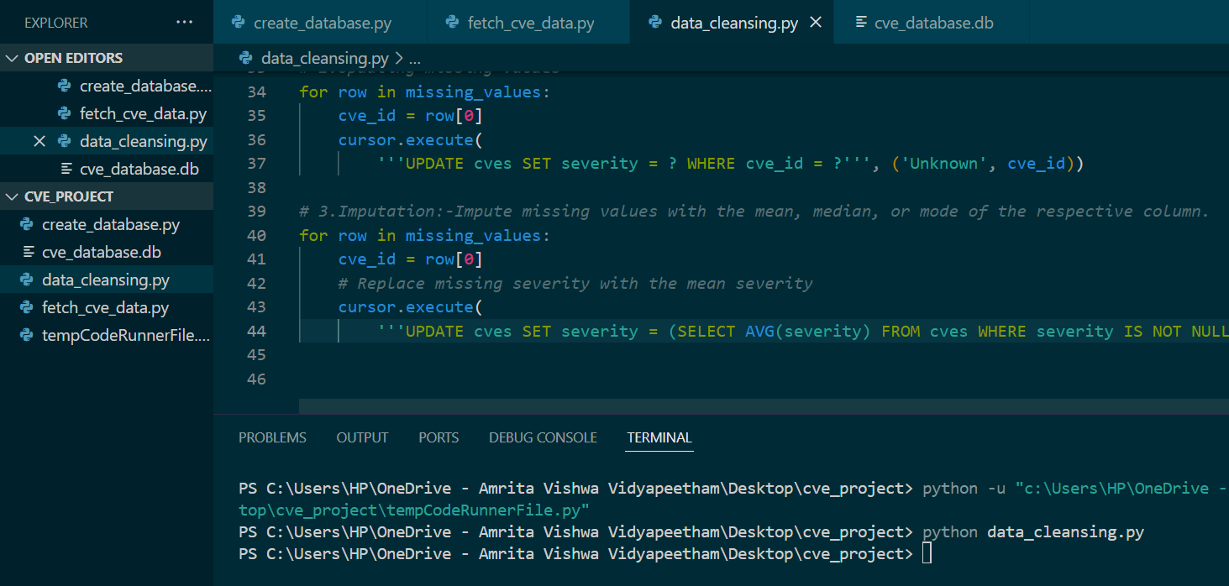

**Step4:- Periodic synchronization of CVE details into the database using a scheduler library like schedule in Python, follow these steps:**

**4.a>Install Schedule Library: First, install the schedule library if you haven't already. You can install it via pip:**

1. **Write Synchronization Function: Write a function to synchronize CVE details into the database. This function should fetch data from the NVD CVE API and update the database accordingly.**
2. **Define Schedule: Define a schedule for how often you want the synchronization to occur. For example, if you want it to run daily at midnight, you can define it accordingly.**
3. **Start Scheduler: Start the scheduler and let it run continuously in the background.**

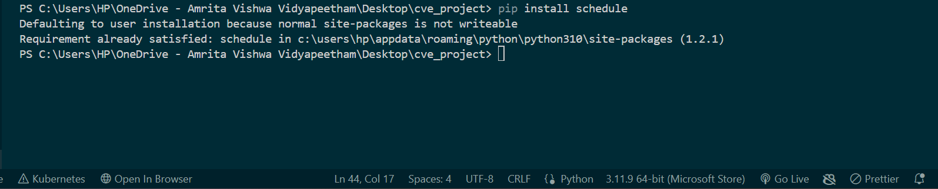

import time

import json

import requests

import sqlite3

**def** synchronize_cve_data():

*# Make API call to fetch CVE data*

    response = requests.get('https://services.nvd.nist.gov/rest/json/cves/2.0')

    cve_data = response.json()

*# Process and update database*

    conn = sqlite3.connect(

**r**'C:\Users\HP\OneDrive - Amrita Vishwa Vidyapeetham\Desktop\cve_project\cve_database.db')

    cursor = conn.cursor()

*# Insert or update CVE details in the database*

    for cve in cve_data['CVE_Items']:

        cve_id = cve['cve']['CVE_data_meta']['ID']

        cve_description = cve['cve']['description']['description_data'][0]['value']

        cve_published_date = cve['publishedDate']

        cve_last_modified_date = cve['lastModifiedDate']

        cve_score = None

        if 'baseMetricV2' in cve['impact']:

            cve_score = cve['impact']['baseMetricV2']['cvssV2']['baseScore']

        elif 'baseMetricV3' in cve['impact']:

            cve_score = cve['impact']['baseMetricV3']['cvssV3']['baseScore']

*# Insert or replace CVE details into the database*

        cursor.execute("INSERT OR REPLACE INTO cve_table (cve_id, description, published_date, last_modified_date, score) VALUES (?, ?, ?, ?, ?)",

                       (cve_id, cve_description, cve_published_date, cve_last_modified_date, cve_score))

    conn.commit()

    conn.close()

**def** run_scheduler():

    while True:

*# Get the current time*

        current_time = time.localtime()

*# Check if it's midnight (00:00)*

        if current_time.tm_hour == 0 and current_time.tm_min == 0:

*# Call the synchronize_cve_data function*

            synchronize_cve_data()

*# Sleep for 1 minute*

        time.sleep(60)

if __name__ == "__main__":

    run_scheduler()

**Step 5:-Checking Unit test cases**

import unittest

from main import get_cves

**class** TestGetCves(unittest.TestCase):

**def** test_successful_retrieval(self):

*# Adjust start_index and results_per_page as needed*

        cves = get_cves(0, 1)

        self.assertIsInstance(cves, dict)

        self.assertIn("totalResults", cves)

*# Add more test cases for different scenarios (e.g., error handling)*

if __name__ == "__main__":

    unittest.main()

import unittest

from main import get_cves

**class** TestGetCves(unittest.TestCase):

**def** test_successful_retrieval(self):

*# Adjust start_index and results_per_page as needed*

        cves = get_cves(0, 1)

        self.assertIsInstance(cves, dict)

        self.assertIn("totalResults", cves)

**def** test_empty_results(self):

*# Simulate a scenario with potentially non-empty results*

        cves = get_cves(10000, 1)  *# Adjust start_index as needed*

        self.assertIsInstance(cves, dict)

        self.assertGreater(cves.get("totalResults", 0),

                           0)  *# Check for non-zero*

**def** test_error_handling(self):

*# Mock a failed request (replace with actual error handling)*

**def** mock_get_cves(*args, **kwargs):

            raise Exception("Simulated error")

        with self.assertRaises(Exception):

            get_cves = mock_get_cves  *# Patch the function for testing*

            get_cves(0, 1)

if __name__ == "__main__":

    unittest.main()

* Output of passed unit test cases

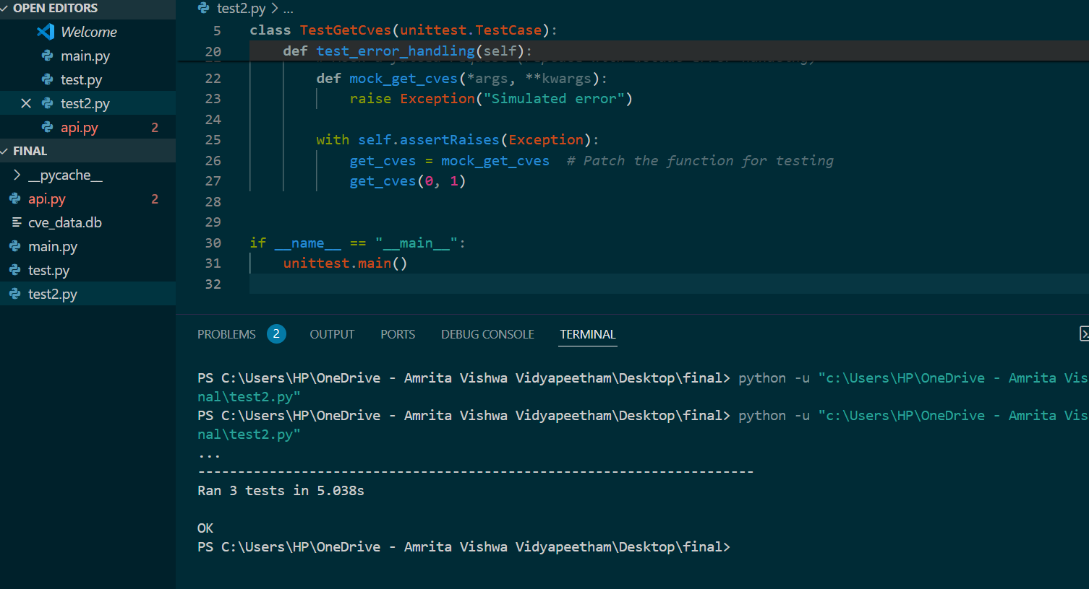

Step 6:-API documentations for each operations(api.py)

from flask import Flask, jsonify, request

import sqlite3

app = Flask(__name__)

**def** get_cve_by_id(cve_id):

    conn = sqlite3.connect("cve_data.db")

    cursor = conn.cursor()

    cursor.execute("SELECT * FROM cves WHERE cve_id = ?", (cve_id,))

    row = cursor.fetchone()

    conn.close()

    if row:

        return jsonify(dict(zip(cursor.description[1:], row)))

    else:

        return jsonify({"error": "CVE not found"}), 404

**def** get_cves_by_year(year):

    conn = sqlite3.connect("cve_data.db")

    cursor = conn.cursor()

    cursor.execute(

        "SELECT * FROM cves WHERE publishedDate LIKE ?", (f"{year}%",))

    rows = cursor.fetchall()

    conn.close()

    return jsonify([dict(zip(cursor.description[1:], row)) for row in rows])

**def** get_cves_by_score_range(min_score, max_score):

    conn = sqlite3.connect("cve_data.db")

    cursor = conn.cursor()

    if min_score is None and max_score is None:

        cursor.execute("SELECT * FROM cves")

    else:

        query = "SELECT * FROM cves WHERE cvss_v2_score BETWEEN ? AND ?"

        cursor

**Step 7:-Website Design**

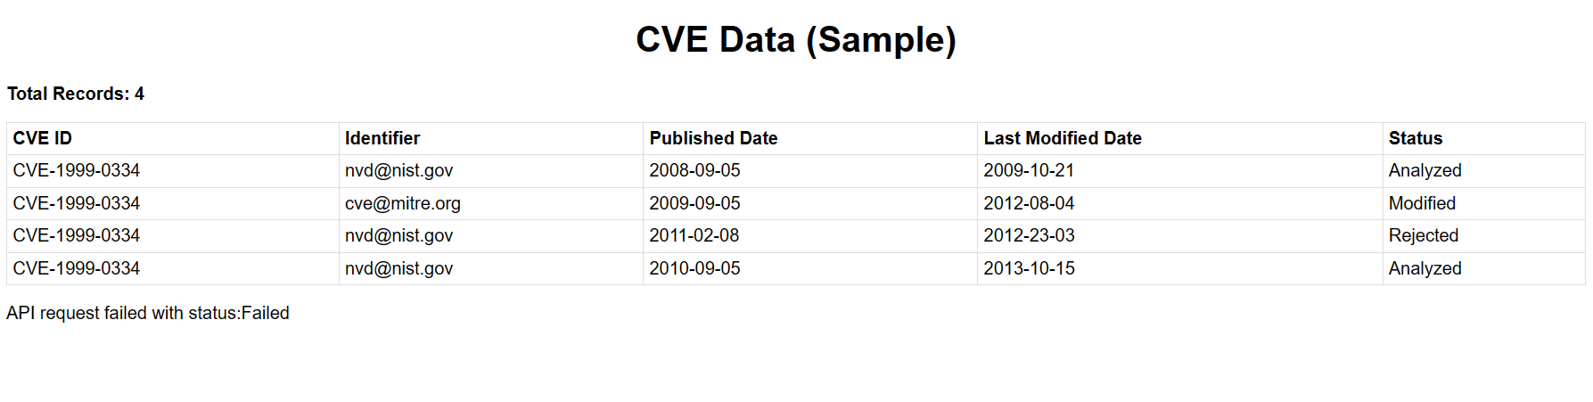

Index.html

<!DOCTYPE html>

<html lang="en">

<head>

    <meta charset="UTF-8">

    <meta name="viewport" content="width=device-width, initial-scale=1.0">

    <title>CVE Data</title>

    <link rel="stylesheet" href="style.css">

</head>

<body>

    <h1>CVE Data</h1>

    <div id="total-records">

        <p>Total Records: <span id="total-count"></span></p>

    </div>

    <table id="cve-table">

        <thead>

            <tr>

                <th>CVE ID</th>

                <th>Identifier</th>

                <th>Published Date</th>

                <th>Last Modified Date</th>

                <th>Status</th>

            </tr>

        </thead>

        <tbody id="cve-data"></tbody>

    </table>

    <script src="script.js"></script>

</body>

</html>

Script.js

**const** cveTable = document.getElementById('cve-table');

**const** cveDataContainer = document.getElementById('cve-data');

**const** totalCountSpan = document.getElementById('total-count');

**const** loadingIndicator = document.createElement('p'); *// New element for loading indicator*

**function** updateTable(data, totalCount) {

    cveDataContainer.innerHTML = ''; *// Clear previous content*

    totalCountSpan.textContent = totalCount;

    data.forEach(cve **=>** {

**const** row = document.createElement('tr');

**const** cveIdCell = document.createElement('td');

        cveIdCell.textContent = cve.cve_id;

**const** identifierCell = document.createElement('td');

        identifierCell.textContent = cve.cve_data_meta ? .id || "-"; *// Adjust based on API response structure*

        const publishedDateCell = document.createElement('td');

        publishedDateCell.textContent = cve.publishedDate;

        const lastModifiedDateCell = document.createElement('td');

        lastModifiedDateCell.textContent = cve.lastModifiedDate;

        const statusCell = document.createElement('td');

        statusCell.textContent = cve.cve_data_meta ? .status || "-"; *// Adjust based on API response structure*

        row.appendChild(cveIdCell);

        row.appendChild(identifierCell);

        row.appendChild(publishedDateCell);

        row.appendChild(lastModifiedDateCell);

        row.appendChild(statusCell);

        cveDataContainer.appendChild(row);

    });

}

*// Replace with the actual NVD API endpoint URL*

const apiUrl = 'https://services.nvd.nist.gov/rest/json/cves/2.0';

**function** fetchData() {

    loadingIndicator.textContent = "Loading CVE data...";

    cveDataContainer.appendChild(loadingIndicator);

    fetch(apiUrl)

        .then(response **=>** {

            loadingIndicator.remove(); *// Remove loading indicator on success*

            if (!response.ok) {

                throw new Error(`API request failed with status: ${response.status}`);

            }

            return response.json();

        })

        .then(data **=>** {

*// Assuming "totalResults" gives the total count*

            updateTable(data.results, data.totalResults);

        })

        .catch(error **=>** {

            console.error('Error fetching CVEs:', error);

*// More informative error handling*

            if (error.message.includes('404')) {

                cveDataContainer.innerHTML = '<p>API endpoint not found.</p>';

            } else if (error.message.includes('429')) {

                cveDataContainer.innerHTML = '<p>API rate limit exceeded. Please try again later.</p>';

            } else {

                cveDataContainer.innerHTML = '<p>Error retrieving CVE data.</p>';

            }

        });

}

fetchData();